**SYNTAX:-**

mkdir [OPTION….] [DIRECTORY….]

**EXPLANATION:-**

**mkdir** command is used to create directory in the current working directory.

For example,

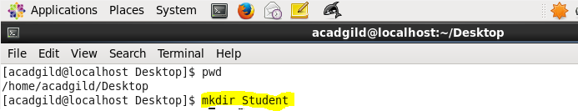

After running the above command, directory called Student is created in current working directory. Here current working directory Is Desktop.

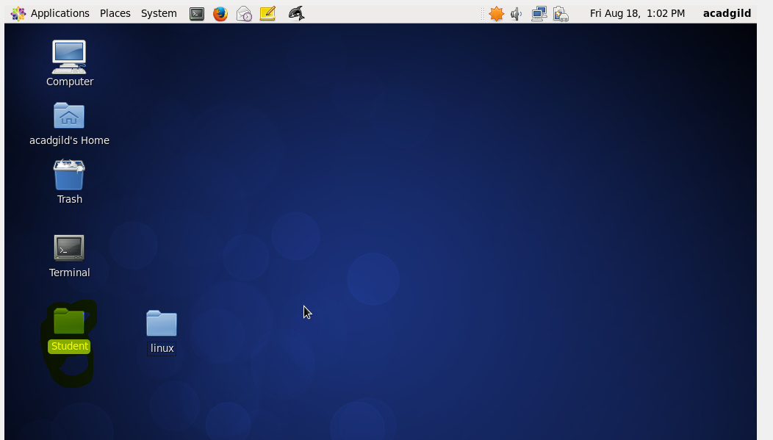

**mkdir –p:-**

-p in mkdir creates specified intermediate directories for new directories if they already do not exists.

If already exists, no effect will be made.

For example,

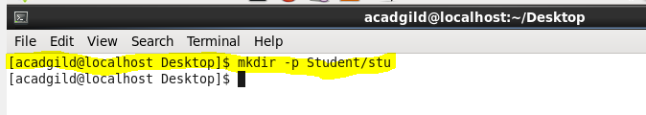

After running above command, subdirectory called stu is created under directory Student as shown in below image.

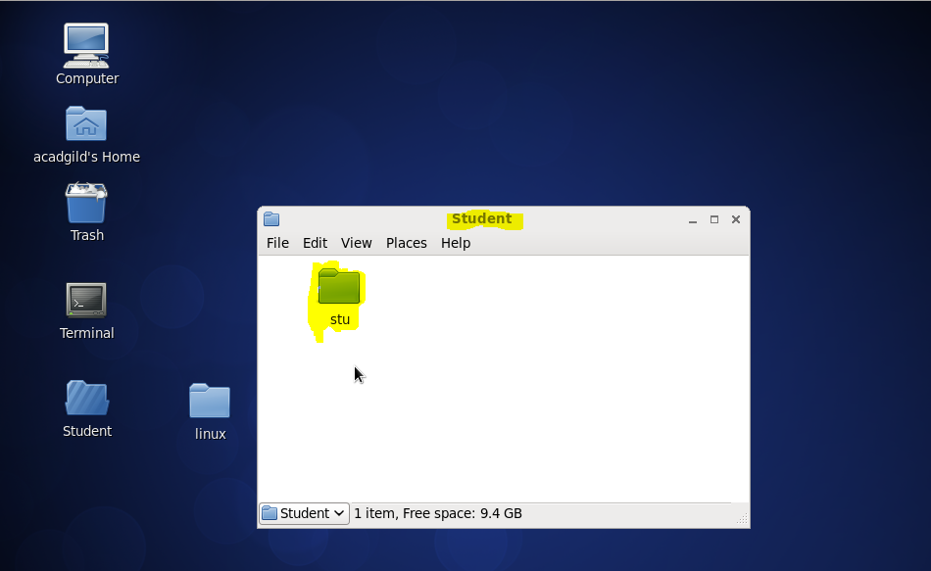

**mkdir –m:-**

-m under mkdir command is used to give read, write, execute permissions to the file. By Default, newly created files will have all these permission.